Known issues with IAR:
Procedure to import project generated from START to IAR EW is available here. It may throw following error when built.
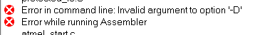
To rectify this, follow the steps given below. Note: Even after following these procedures, compilation may fail due to non-touch files.
- Remove the .ipcf file from project. Right-click on .ipcf file name and click Remove.
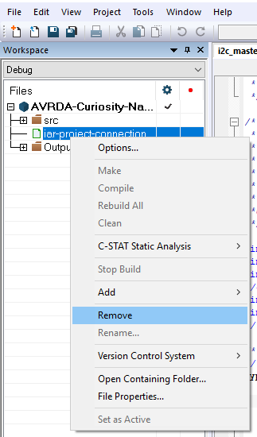
- Right Click on project and Selection Options.
- Go to Assembler option. Select Preprocessor tab and remove device name definition from Defined Symbols.
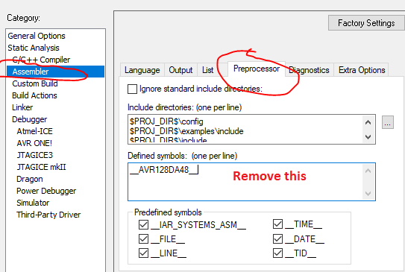
- Now build should work without any issue.

